9 SCIENCE EARTH AND SPACE SCIENCE TSUNAMI ASSIGNMENT 2015


Name: __________________ Teacher: ________________

Form: ___________________ Due date: _______________

Aim: This assignment will allow you to find out how tsunamis occur.

❶ Explain one possible way a tsunami can occur.
You can either:
a) Draw your own diagrams, write in labels and explain them within your explanation.
b) Use a diagram from the internet, write in your own labels and explain them within your explanation.

❷ Research one tsunami that has occurred. In your information include:
a) When it happened.
b) The origin of the tsunami.
c) An explanation of three immediate effects the tsunami had on people and the environment.
d) An explanation of three long term effects of the tsunami.

IMPORTANT INFORMATION

Plagiarism
You must write in your own words not copy sentences word for word from another student or another source.
Plagiarising = instant zero on assignment and you will have to re-do it.

Assessment policy
Have sick note/legitimate reason from parent = new negotiated due date.
Assignment not submitted on due date and no sick note from parents = -20% mark
Assignment not submitted on new negotiated due date = -40% mark
+ Letter home to parents.
+ Must attend academic completion to complete assignment.

If you are not at school the day this assignment is due, please email it to your teacher by 4pm.

Assignment requirements

You will be required to hand in two things:

① This assignment booklet with the completed reference list.

② Your report in one of the following forms:

(If you would like to submit it in a different format, please first check with your teacher.)

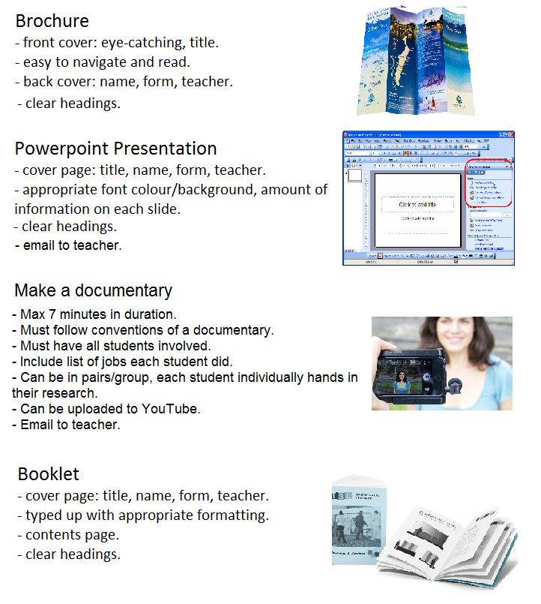

How to reference

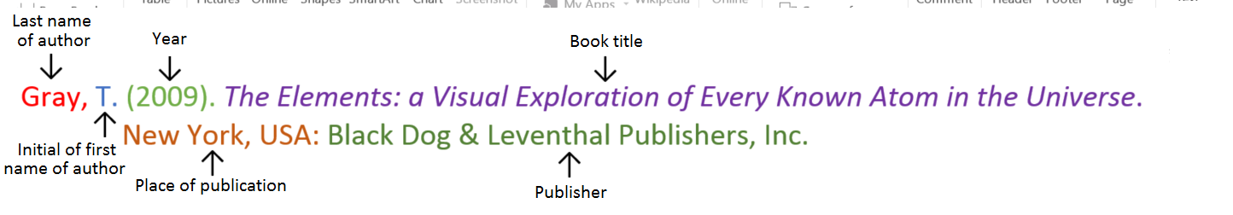
Book
Book with two authors

Shermer, M., & Benjamin, A. (2006). Secrets of Mental Math: The Mathemagician’s Guide to Lightning Calculation and Amazing Mental Math Tricks. New York, USA: Three Rivers Press.

Book with editor

Kasdorf, W. E. (Ed). (2003). The Columbia guide to digital publishing. New York, USA: Columbia University Press.

Book with different editions

Nagle, G., & Cooke, B. (2012). Geography Study Guide: Oxford Ib Diploma Programme (2nd ed.). Oxford, UK: Oxford University Press.

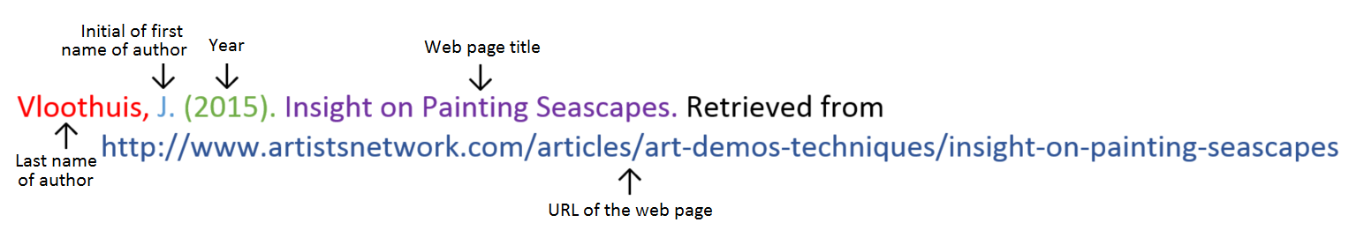
Website

Website with no author (put title of page at the front)

Aranmore Catholic College. (2014). Retrieved from http://www.aranmore.wa.edu.au/

Website with no date

The Zadkine Museum. (n.d). Retrieved http://www.france.fr/en/museums/zadkine-museum.html

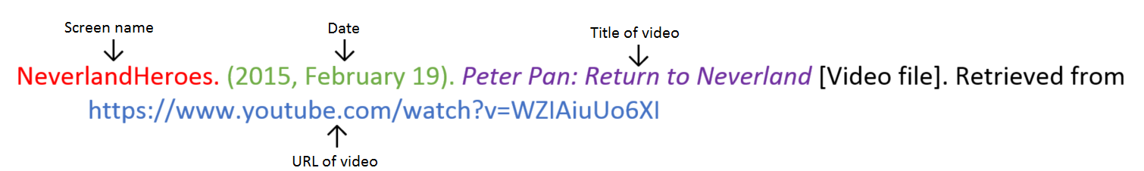
Video file

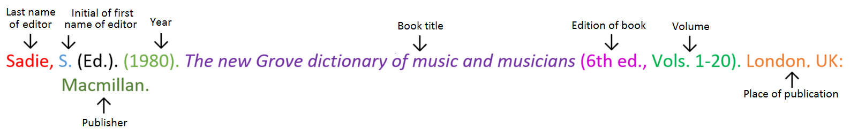
Encyclopaedia or dictionary

References: minimum of three references, from a minimum of two different types of sources.
_________________________________________________________________________________________________

_________________________________________________________________________________________________

_________________________________________________________________________________________________

_________________________________________________________________________________________________

_________________________________________________________________________________________________

_________________________________________________________________________________________________

_________________________________________________________________________________________________

_________________________________________________________________________________________________

_________________________________________________________________________________________________

_________________________________________________________________________________________________

_________________________________________________________________________________________________

_________________________________________________________________________________________________

_________________________________________________________________________________________________

_________________________________________________________________________________________________

_________________________________________________________________________________________________

_________________________________________________________________________________________________

_________________________________________________________________________________________________

_________________________________________________________________________________________________

_________________________________________________________________________________________________

_________________________________________________________________________________________________

_________________________________________________________________________________________________

_________________________________________________________________________________________________

_________________________________________________________________________________________________

_________________________________________________________________________________________________

_________________________________________________________________________________________________

_________________________________________________________________________________________________

_________________________________________________________________________________________________

_________________________________________________________________________________________________

_________________________________________________________________________________________________

Content | Description |  | Your  mark
Information | When the tsunami happened.  The origin of the tsunami.  An explanation of four immediate effects the tsunami had on people and  the environment.  An explanation of four long term effects of the tsunami. | 1  1  8  8
Diagram | Appropriate diagram included.  Diagram has minimum of 5 correct labels.  Adequate explanation of labels. | 1  5  5
Notes | Minimum of 1 page of notes handed in (hand written or typed). | 1
Referencing | Minimum of 3 references.  Minimum of 2 different types of sources used.  Referenced in correct format. | 2  1  1
Presentation | Correct spelling/grammar/clearly spoken.  Written/presented clearly. | 1  1
Total mark |  | 36

Mark as percentage %

Teacher comment:

_________________________________________________________________________________________________

_________________________________________________________________________________________________

_________________________________________________________________________________________________

_________________________________________________________________________________________________

_________________________________________________________________________________________________

_________________________________________________________________________________________________

